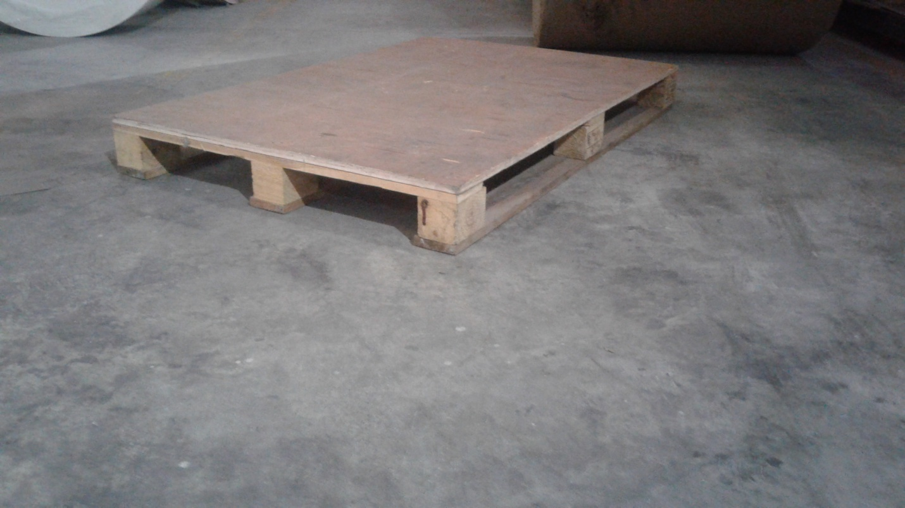

Specification:
Top:12mm plywood
Bottom:18mm plywood
Leg:3x3 (Fine wood)
Reeper:3x1 (fine Wood)

